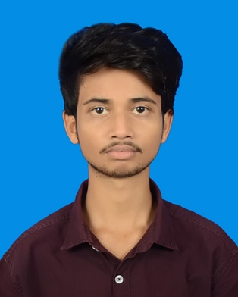**RESUME**

**OF**

**EFTAKHAR AHMED EMON**

**Present Address:**

Middle Paikpara, Ahmed Nagar,

Mirpur-1, Dhaka-1216.

Mobile No:- 01310-443944

*E-mail*: *eftakharahmed4@gmail.com*

**Career objective:**

I have a vision to work with diversity and attempt to meet the deadlines for achieving my goals. I want to connect with such a job, where I can enhance my skill, conquer maximum value and bear out my academic attainments. To acquire a suitable position, which facilities favorable environment and self-development opportunity.

**Commitments**

|  |  |
| --- | --- |
| * Honesty * Regularity * Steadiness | * Endeavor * Sincerity * Promptness |

**Educational Qualification**

**Higher Secondary Certificate (H.S.C)**

* Name of Institution : Madhupur Shahid Smrity Higher Secondary School.
* Group : Humanities
* Board : Dhaka
* Result : 4.33 (Out of 5.00)
* Passing Year : 2019

**Secondary School Certificate (S.S.C)**

* Name of Institution : Madhupur Rani Bhobani Model High School.
* Group : Science
* Board : Dhaka
* Result : 4.59 (Out of 5.00)
* Passing Year : 2017

**Computer Skills**

* MS Word, MS Excel, MS Power-Point, Photoshop & Internet Browsing etc.

**Linguistic Capability**

|  |  |  |  |  |
| --- | --- | --- | --- | --- |
| **Language** | **Writing** | | **Reading** | **Speaking** |
| Bangla | Excellent | | Excellent | Excellent |
| English | Good | | Good | Good |
|  |  |

**Interests**

* Reading Books, Listening music etc.

**Personal Information :**

Full Name : Eftakhar Ahmed Emon

Father’s Name : Akramul Haque

Mother’s Name : Saima Haque

Permanent Address : Vill: Malauri Post: Madhupur

Upazila: Madhupur, Dist: Tangail

Date of Birth : 19-12-2001

Religion : Islam

Marital Status : Unmarried

Gender : Male

Nationality : Bangladeshi

Height : 5`- 3``

Blood Group : A+

NID No : 3312838497

**Declaration:**

**I hereby certify that the above information is true and correct to the best of my knowledge and belief.**

Signature Date:

**Eftakhar Ahmed Emon**